Aspiration Assisted Motor-Driven Biopsy Needle

Report: 1-28-2025

1. **Work Planned to be Completed:**

The main priority this week was debugging the circuit and determining if we would be staying with a RP2040-based board or transitioning to another Arduino device. This meant investigating several software and circuit issues with the project:

1. Motor startup upon powering the device.
2. RPM readings not working correctly.
3. Safety limits on distance not working correctly.
4. Variable inputs deadlocking circuit.
5. Current sensor providing buggy readings.
6. **Work Completed:**

All of the previously mentioned issues have been fixed or worked around to the point where the circuit should adequately address all these functions. Some of this required changes to the actual circuit, in particular the addition of several pull-down resistors in order to lower the voltage being sent to the PWM pin on startup (1). Other issues required changes in the code especially with how interrupts are handled. There were several timing issues with the state machine and our method of counting and keeping track of positional data that have been worked around by using non-standard practices. The current sensor bug (5) was solved by changing the actual component as it turned out to be dysfunctional. Hopefully, I will be able to find a better way to design and implement these functions in the future so that they will not have to be “bandaged” in.

***Figure 1:*** *Interrupt handling for the circuit. Typically, this would not be done like this at all but it works.*

***Figure 2:*** *Current state of the circuit: new INA219 current sensor and pulldown resistor.*

Additionally, this week Carsten lent me a debugger which can be used to set breakpoints and automate the flashing process for the Feather board. Although I don’t quite know how to fully use it yet it will prove to be a very useful development tool in the future. Right now I believe I should be able to use OpenOCD to get this to work. If this proves a simple process, it would be in the best interest of the lab that we acquire a J-Link or at least another debugger for the future.

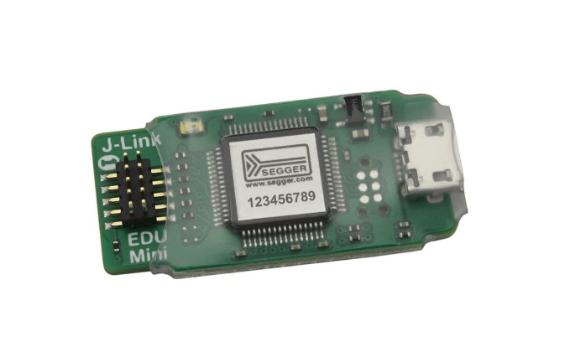

***Figure 3:*** *J-Link EDU mini which will be used to debug and flash the circuit.*

For the MSC, linking the libraries with the CMAKE build system is for the most part done. Although I have been able to configure most of the necessary source files for it to work I am still running into errors. I believe I am very close to getting it working though.

***Figure 4:*** *Trying to use the FatFS and TinyUSB libraries to get the MSC working will require some more work than expected.*

1. **Future Work:**

I believe the MSC is almost near functional. Once this is done I will implement the filtering methods using another state and format the .csv that will be outputted onto the SD card. Then, PCB design will begin.

**Current CEN4908C Due Dates**

|  |  |
| --- | --- |
| *Assignment* | *Due Date* |
| Alpha Build | 2/5 |
| Beta Build | 2/26 |
| Release Candidate | 4/2 |
| Production Release | 4/17 |
| Post-Mortem | 4/23 |